**Lab 06 - Implement Traffic Management**

***Mihail Elencevski***

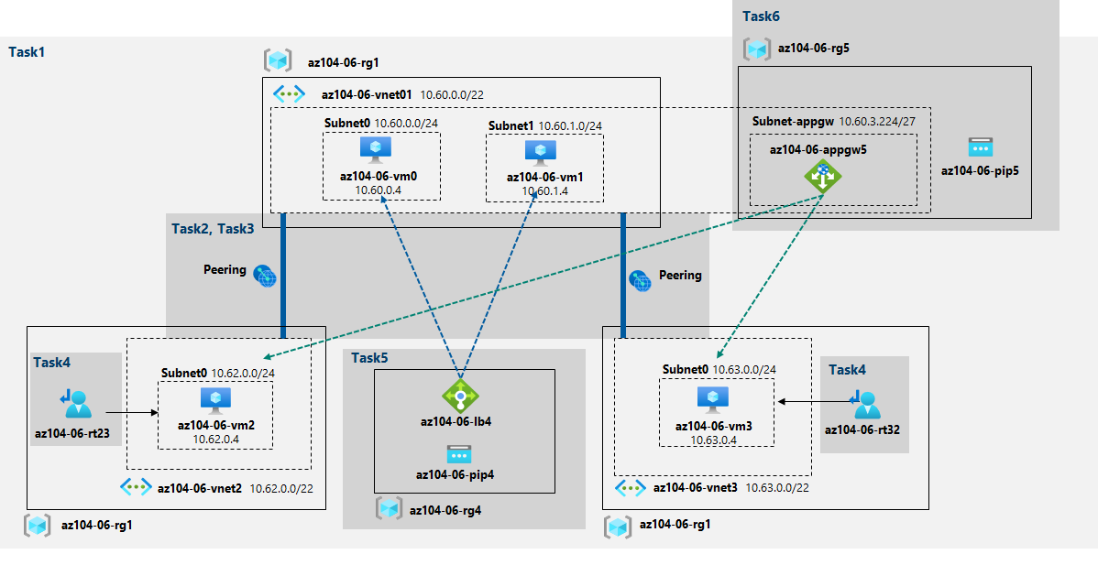

#### Task 1: Provision the lab environment

I uploaded 2 files **az104-06-vms-loop-template.json** and **az104-06-vms-loop-parameters.json and changed the password in the second file.**

**At number 1 in the picture below I am naming the region, naming the resorce group name and creating the resource group in the desired location. At number 2 I am creating the three virtual networks and four VMs. At number 3 I am** installing the Network Watcher extension.

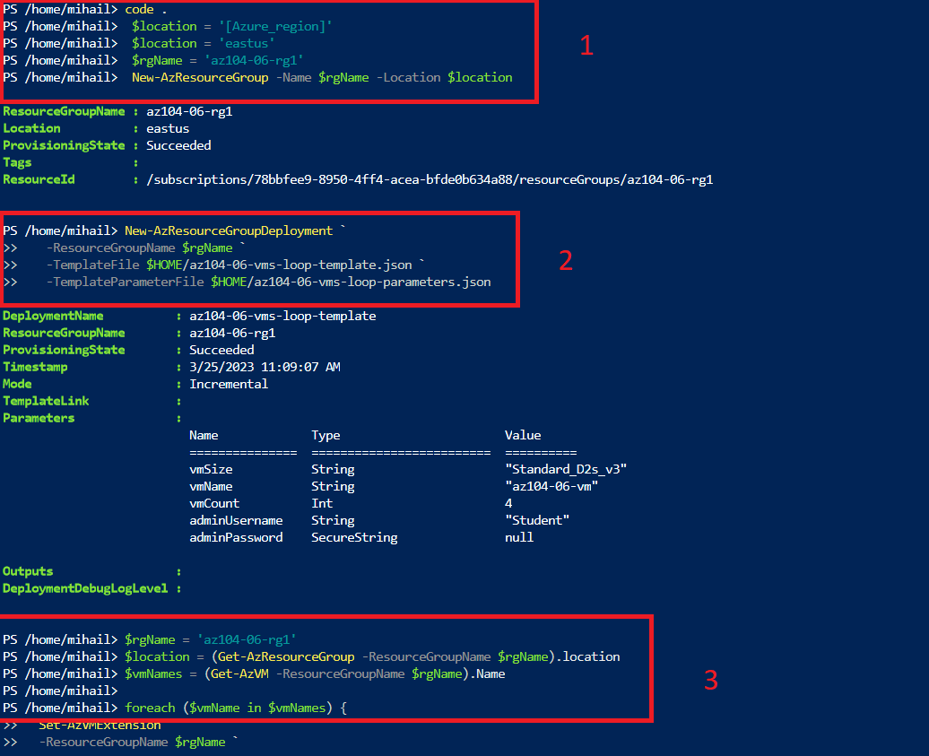

#### Task 2: Configure the hub and spoke network topology

In this task I am configuring a hub and spoke network topology by creating local peering between the virtual networks I deployed in the previous task. This involves navigating the Azure portal and setting up two local peerings for each spoke virtual network to connect to the hub virtual network.

In the pictures bellow are the Peerings I created for the Virtual Networks

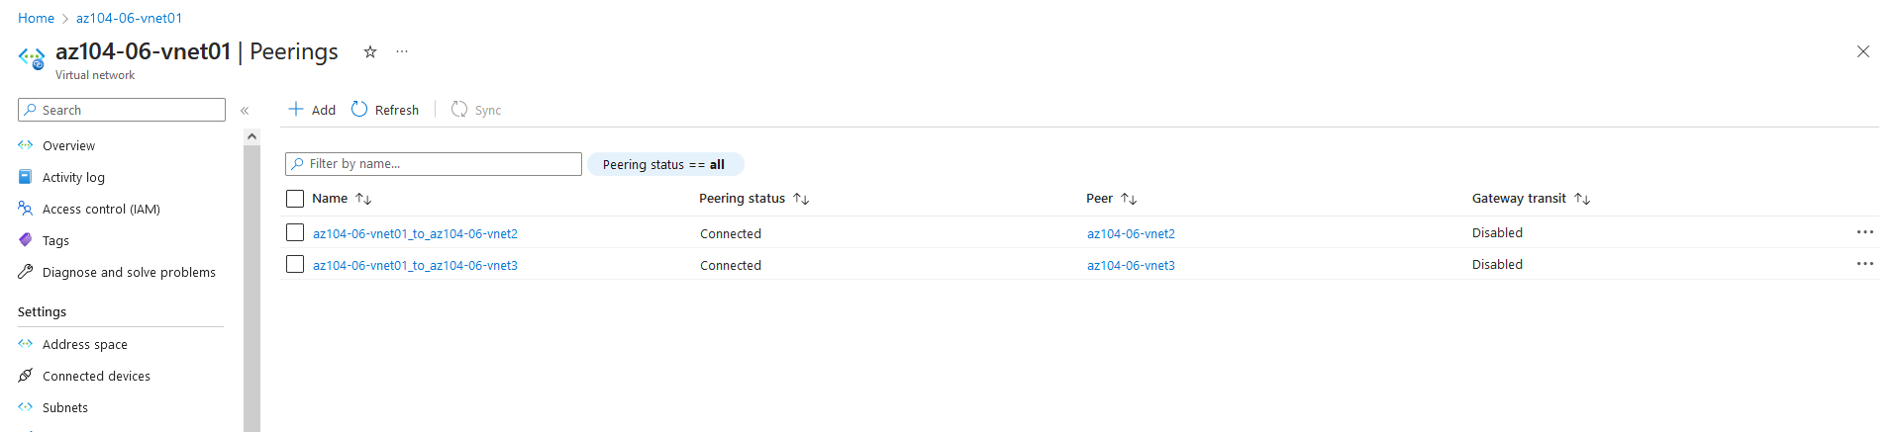

This step establishes two local peerings - one from az104-06-vnet01 to az104-06-vnet2 and the other from az104-06-vnet2 to az104-06-vnet01.

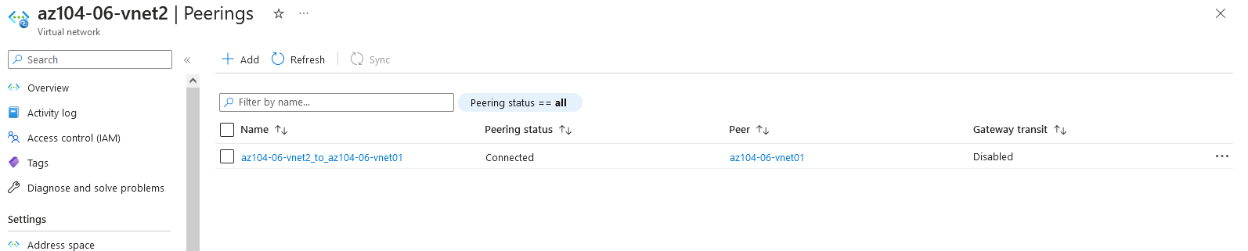

This step establishes two local peerings - one from az104-06-vnet01 to az104-06-vnet3 and the other from az104-06-vnet3 to az104-06-vnet01. This completes setting up the hub and spoke topology (with two spoke virtual networks).

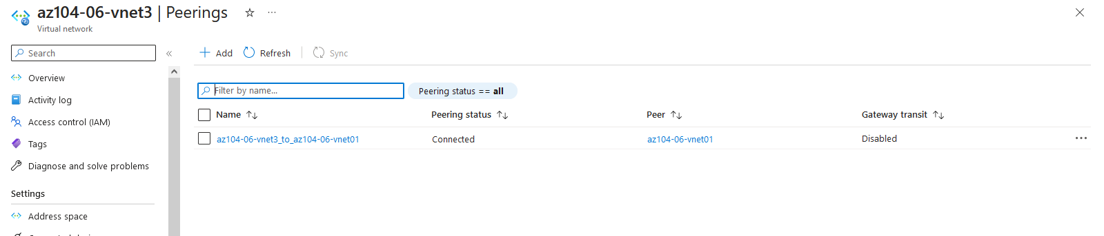

#### Task 3: Test transitivity of virtual network peering

This task involves testing the transitivity of virtual network peering using Network Watcher in Azure portal. By initiating connectivity checks between virtual machines in different virtual networks, we can determine if the peering connections are direct or intermediate, and if virtual network peering is transitive in some way.

The diagnostic tests ran succesfully.

**10.62.0.4** represents the private IP address of **az104-06-vm2**

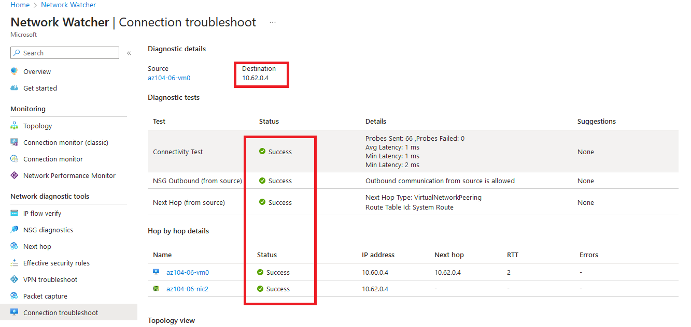

**10.63.0.4** represents the private IP address of **az104-06-vm3**

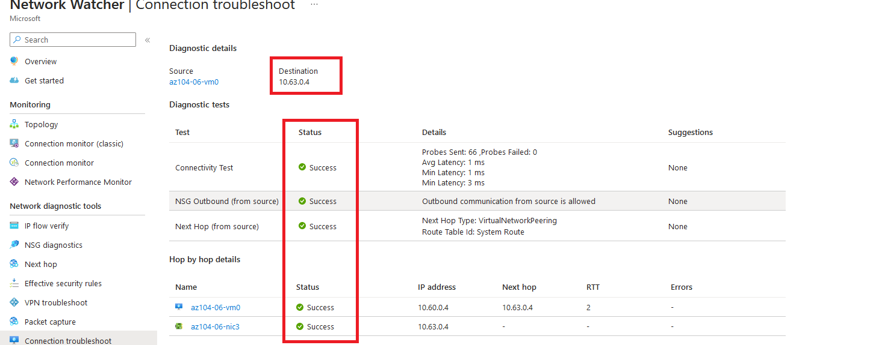

Here the connection to the VM2 unreaceable. Because the two spoke virtual networks are not peered with each other (virtual network peering is not transitive).

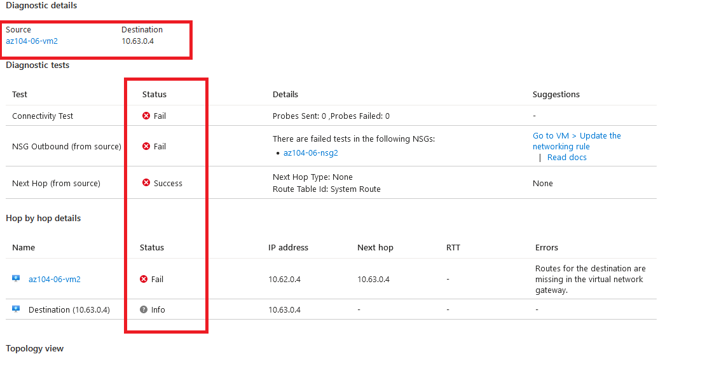

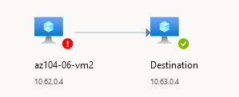

#### Task 4: Configure routing in the hub and spoke topology

This task involves configuring routing between two spoke virtual networks in Azure. This is done by enabling IP forwarding on a virtual machine, configuring user-defined routes on the spoke virtual networks, and creating and associating route tables with the appropriate subnets. A network connection troubleshoot is initiated to verify connectivity.

Before I created the routing tables in the picture bellow I used the **RunPowerShellScript blade to install** Remote Access Windows Server role and to install Routing role service.

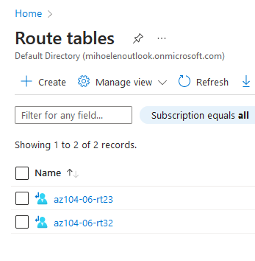

Here is the route table **az104-06-rt23 with subnet0**

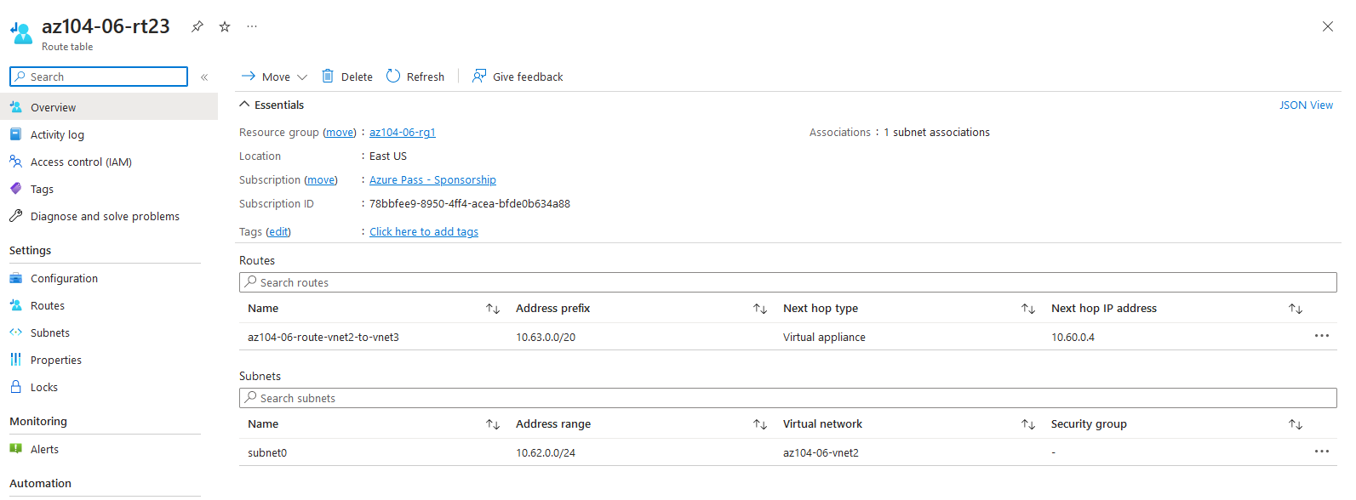

Here is the route table **az104-06-rt32 with subnet0**

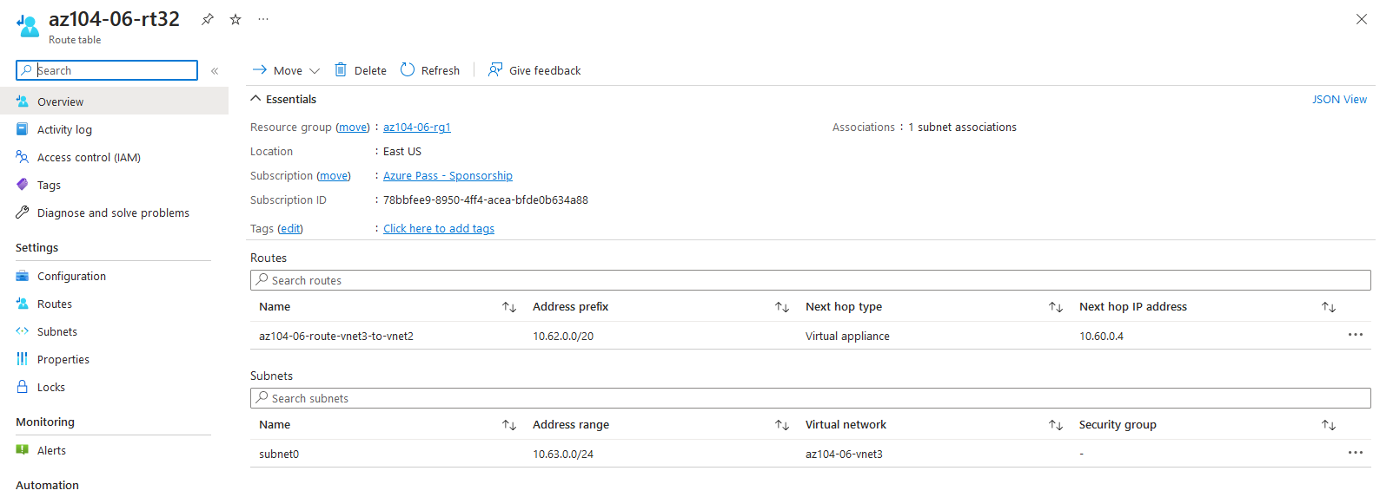

There seems to be a problem with the VM starting but there is no info that there is a mistake with the connection.

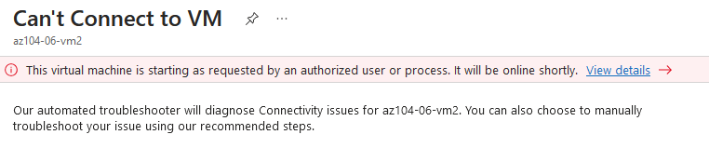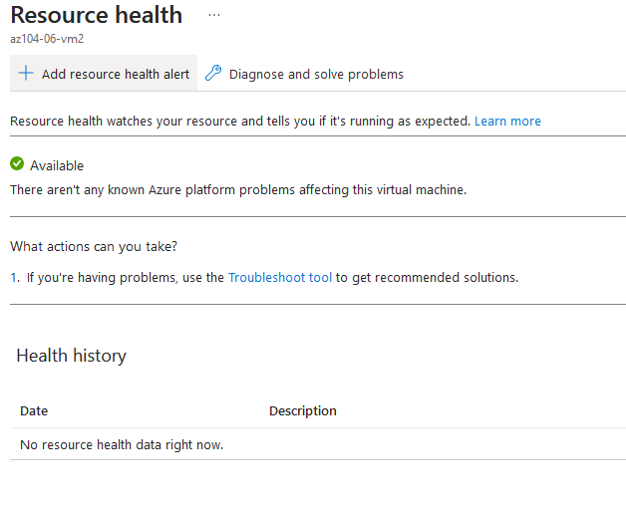

So here is the end of the task. It says that **IP forwarding is not enabled** but bellow this picture I am showing that I enabled it, so I think it needs to take some time to confiqure. But the task is completed successfully.

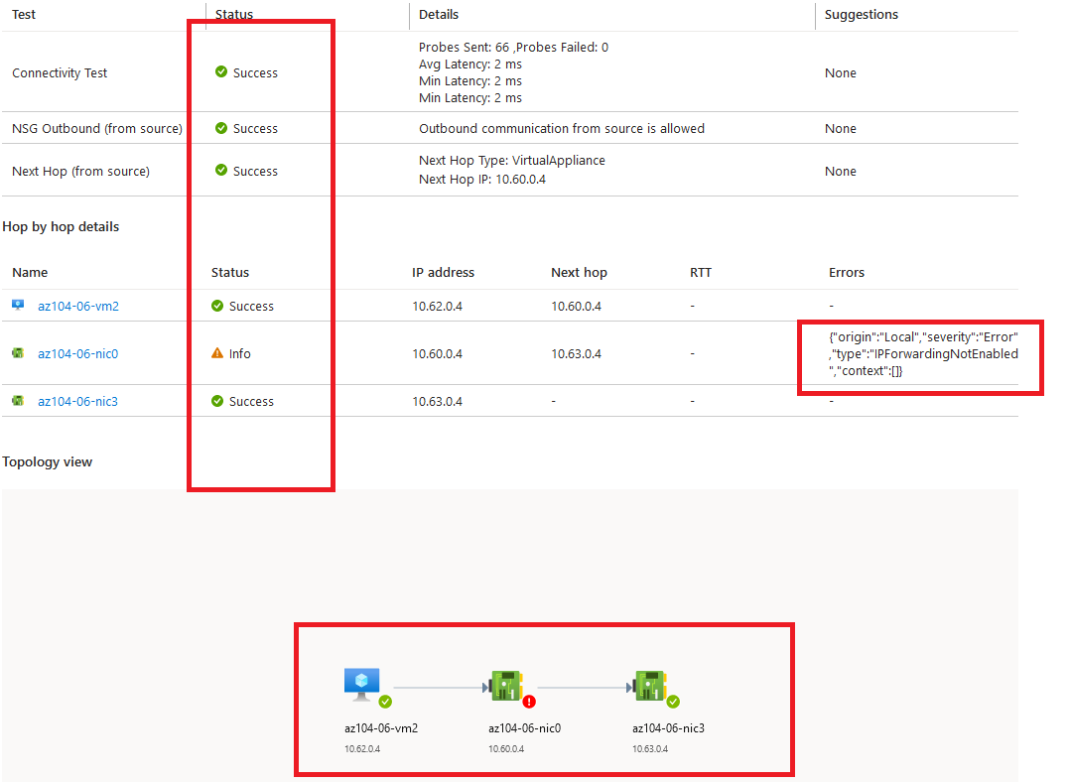

Here is the IP Forwarding:

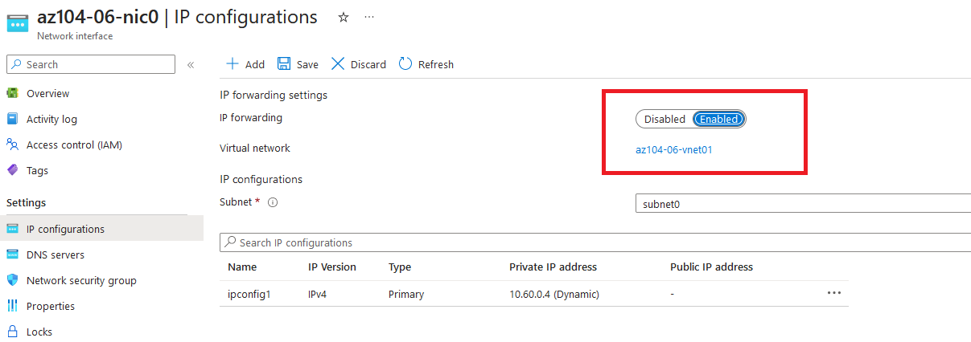

#### Task 5: Implement Azure Load Balancer

In this scenario I am implementing an Azure Load Balancer in front of two Azure virtual machines in the hub virtual network. Creating a load balancer with backend pools, load balancing rules, and health probes to rotate through virtual machines and distribute traffic. And verifing load balancing functionality by accessing the load balancer's IP address.

In the picture below I am showing that I succesfully created a **load balancer** and I am taking the Ip address from the **Frontend Ip confiquration** and pasting it in a new browser window to show the message **Hello World from az104-06-vm0** or **Hello World from az104-06-vm1**.

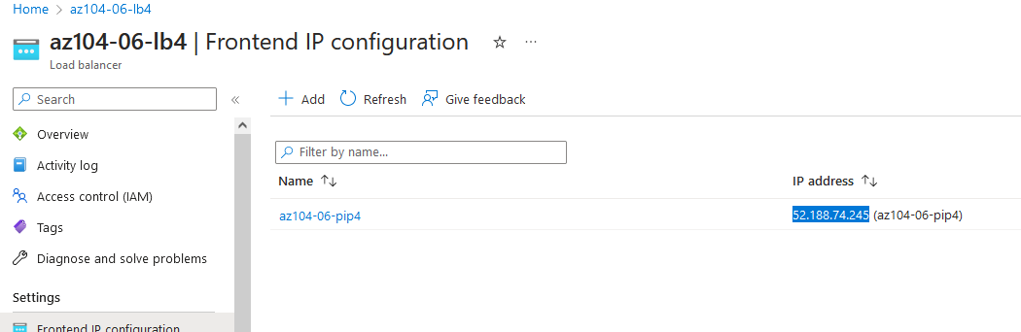

Here is the output of the Ip Address:

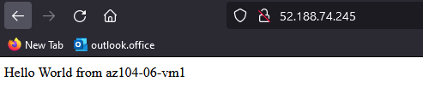

Here is the output when I refresh the page:

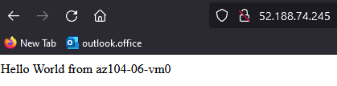

#### Task 6: Implement Azure Application Gateway

Here I am implementing an Azure Application Gateway in front of the two Azure virtual machines in the spoke virtual networks.

In this picture I am showing the subnet that I created and showing that the **Application Gateway** requires a dedicated subnet of /27 or larger size.

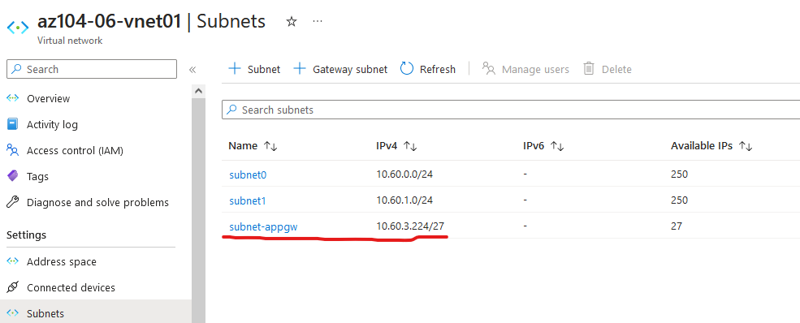

Application gateway deployed.

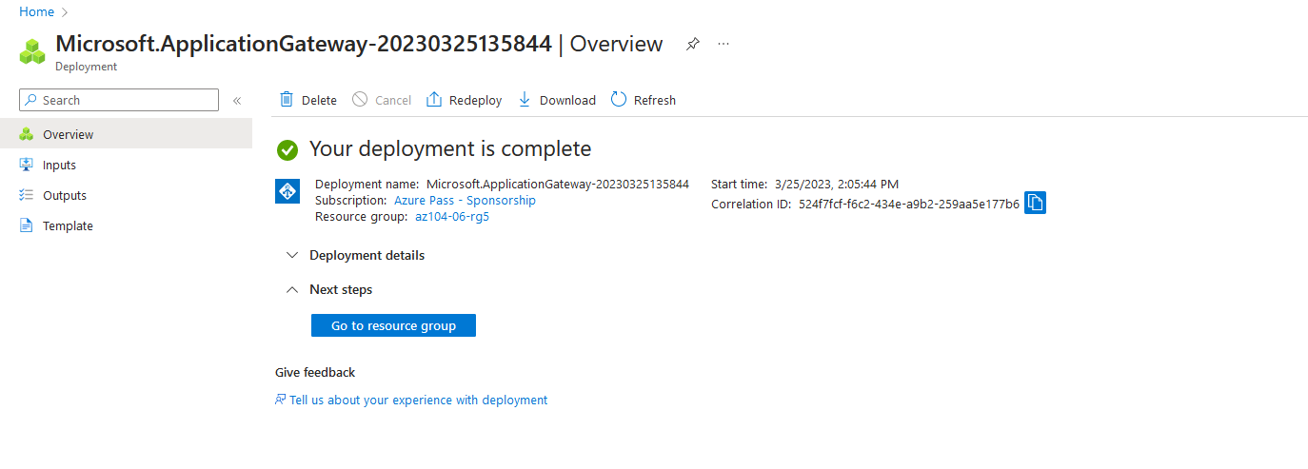

**On the az104-06-appgw5** Application Gateway blade I am copying the **Frontend public IP address**, and pasting it in a new browser tab. And I show the message that is displayed:

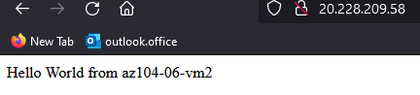

Here is when I refresh the page:

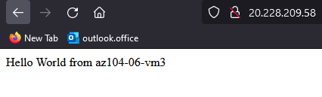

**Cleaning up resources**